1.

Xml:

<?xml version="1.0" encoding="utf-8"?>

<RelativeLayout xmlns:android="http://schemas.android.com/apk/res/android"

xmlns:tools="http://schemas.android.com/tools"

android:layout_width="match_parent"

android:layout_height="match_parent"

tools:context=".MainActivity">

<TextView

android:layout_width="wrap_content"

android:layout_height="wrap_content"

android:text="Hello World, Toast Example"

android:textSize="20dp"

android:layout_marginTop="10dp"

android:layout_marginLeft="10dp"

android:layout_marginBottom="5dp"

android:id="@+id/txt"

/>

<Button

android:id="@+id/showToastButton"

android:layout_width="wrap_content"

android:layout_height="wrap_content"

android:text="Show Toast"

android:layout_below="@+id/txt"

android:layout_marginLeft="10dp"

android:layout_marginTop="0dp"

android:layout_alignParentLeft="true"

android:onClick="showCustomToast"/>

</RelativeLayout>

Java:

package com.example.practical1501;

import android.os.Bundle;

import android.view.Gravity;

import android.view.LayoutInflater;

import android.view.View;

import android.widget.Button;

import android.widget.TextView;

import android.widget.Toast;

import androidx.appcompat.app.AppCompatActivity;

public class MainActivity extends AppCompatActivity {

@Override

protected void onCreate(Bundle savedInstanceState) {

super.onCreate(savedInstanceState);

setContentView(R.layout.activity_main);

Button showToastButton = findViewById(R.id.showToastButton);

}

public void showCustomToast(View view) {

LayoutInflater inflater = getLayoutInflater();

View layout = inflater.inflate(R.layout.custom_toast, findViewById(R.id.customToastLayout));

TextView text = layout.findViewById(R.id.customToastText);

text.setText("Message for you\nYou have got mail!");

Toast toast = new Toast(getApplicationContext());

toast.setGravity(Gravity.CENTER_VERTICAL, 0, 0);

toast.setDuration(Toast.LENGTH_LONG);

toast.setView(layout);

toast.show();

}

}

Output:

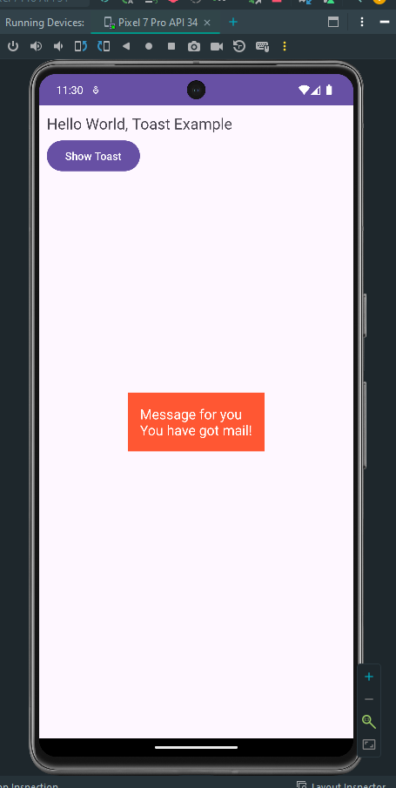  
2.

Xml:

<?xml version="1.0" encoding="utf-8"?>

<RelativeLayout xmlns:android="http://schemas.android.com/apk/res/android"

xmlns:tools="http://schemas.android.com/tools"

android:layout_width="match_parent"

android:layout_height="match_parent"

tools:context=".MainActivity">

<CheckBox

android:id="@+id/checkboxItem1"

android:layout_width="wrap_content"

android:layout_height="wrap_content"

android:text="Pizza"

android:layout_centerHorizontal="true"

android:layout_marginTop="50dp"/>

<CheckBox

android:id="@+id/checkboxItem2"

android:layout_width="wrap_content"

android:layout_height="wrap_content"

android:text="Coffee"

android:layout_below="@+id/checkboxItem1"

android:layout_centerHorizontal="true"

android:layout_marginTop="20dp"/>

<CheckBox

android:id="@+id/checkboxItem3"

android:layout_width="wrap_content"

android:layout_height="wrap_content"

android:text="Burger"

android:layout_below="@+id/checkboxItem2"

android:layout_centerHorizontal="true"

android:layout_marginTop="20dp"/>

<Button

android:id="@+id/orderButton"

android:layout_width="wrap_content"

android:layout_height="wrap_content"

android:text="Order"

android:layout_below="@+id/checkboxItem3"

android:layout_marginTop="80dp"

android:layout_centerHorizontal="true"

android:onClick="orderItems"/>

</RelativeLayout>

Java:

package com.example.practical1502;

import android.os.Bundle;

import android.view.View;

import android.widget.CheckBox;

import android.widget.Toast;

import androidx.appcompat.app.AppCompatActivity;

public class MainActivity extends AppCompatActivity {

@Override

protected void onCreate(Bundle savedInstanceState) {

super.onCreate(savedInstanceState);

setContentView(R.layout.activity_main);

}

public void orderItems(View view) {

CheckBox checkboxItem1 = findViewById(R.id.checkboxItem1);

CheckBox checkboxItem2 = findViewById(R.id.checkboxItem2);

CheckBox checkboxItem3 = findViewById(R.id.checkboxItem3);

StringBuilder orderDetails = new StringBuilder("Selected Items:\n");

if (checkboxItem1.isChecked()) {

orderDetails.append("Pizza\n");

}

if (checkboxItem2.isChecked()) {

orderDetails.append("Coffee\n");

}

if (checkboxItem3.isChecked()) {

orderDetails.append("Burger\n");

}

double totalPrice = calculateTotalPrice(checkboxItem1.isChecked(), checkboxItem2.isChecked(), checkboxItem3.isChecked());

orderDetails.append("Total Price: Rs").append(String.format("%.2f", totalPrice));

Toast.makeText(this, orderDetails.toString(), Toast.LENGTH_LONG).show();

}

private double calculateTotalPrice(boolean item1Selected, boolean item2Selected, boolean item3Selected) {

double pricePerItem1 = 99;

double pricePerItem2 = 50;

double pricePerItem3 = 120;

int quantity1 = item1Selected ? 1 : 0;

int quantity2 = item2Selected ? 1 : 0;

int quantity3 = item3Selected ? 1 : 0;

return (quantity1 * pricePerItem1) + (quantity2 * pricePerItem2) + (quantity3 * pricePerItem3);

}

}

Output:

